PWA Video 26 – offline data

<https://www.youtube.com/watch?v=ciu62KLlwGQ>

Any new doc added results in callback function being fired and renderRecipe being called 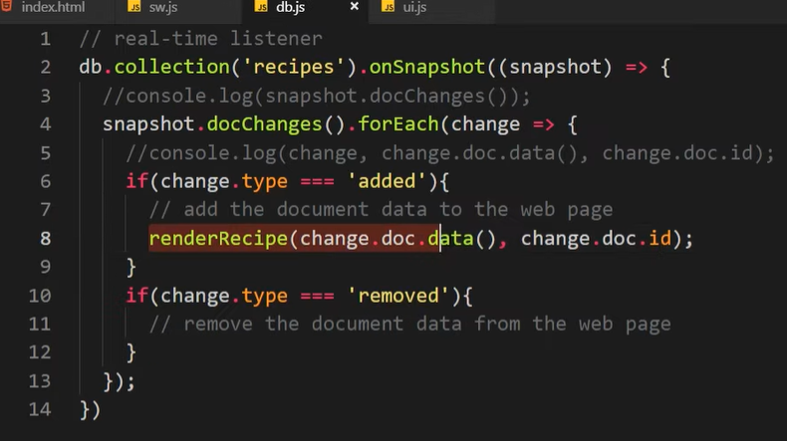

Then out put the data to the DOM

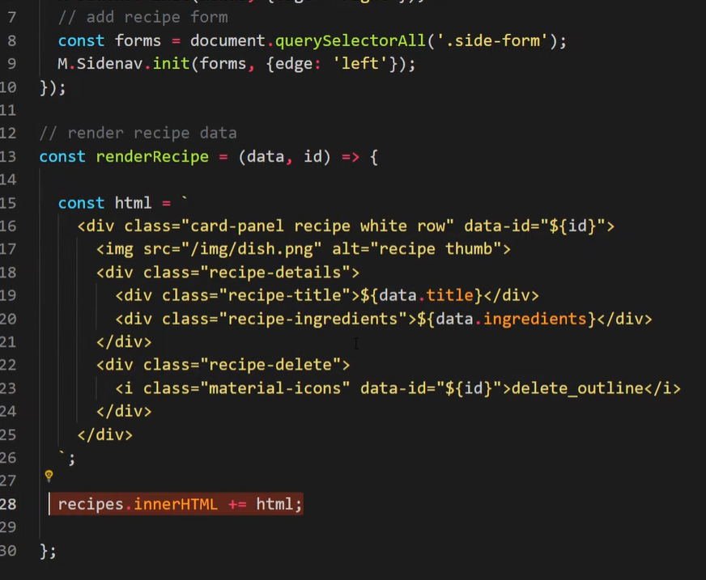

Using service worker to put the data on the page would result in old data being displayed when off line

So instead of caching ? use IndexedDB API

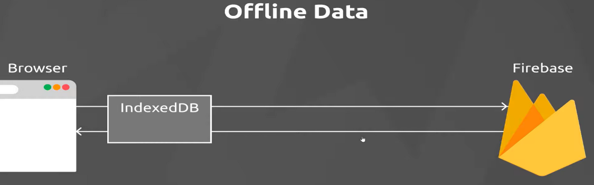

<https://developer.mozilla.org/en-US/docs/Web/API/IndexedDB_API>

Can store info in indexed db to use locally so we can get it and show on the page

If we add a new recipe to indexed while offline we can create and then when back on line save to the DB

Firestore makes this easy, if doing a manual implementation it is much more complicated.

Firestore hooks into IndexedDB and handles if

Just need to enable it in Firebase Firestore database

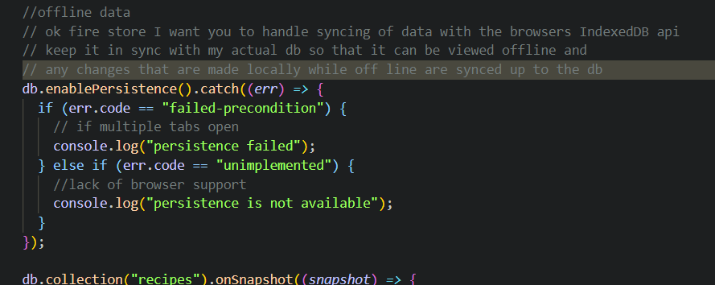

Then uncomment the service worker and add an if statements to prevent SW from putting database stuff into cache

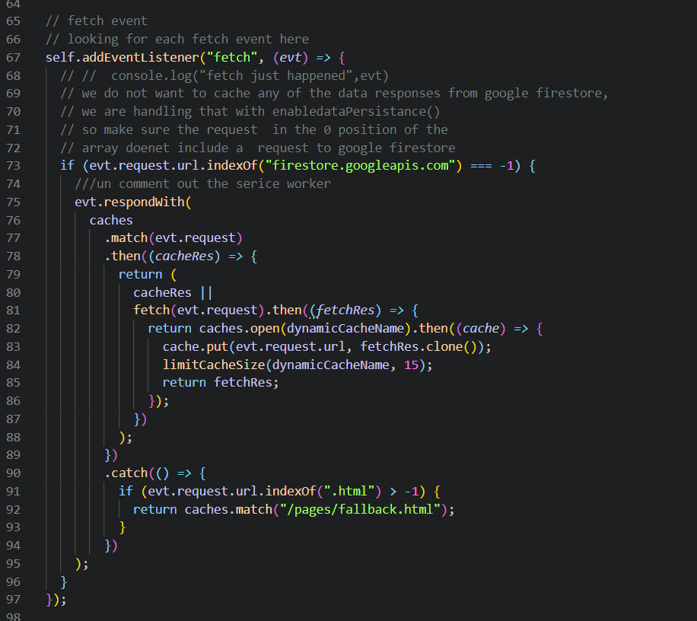

Getting error message

Uncaught (in promise) TypeError: Request scheme 'chrome-extension' is unsupported

at sw.js:83

<https://github.com/iamshaunjp/pwa-tutorial/issues/1>

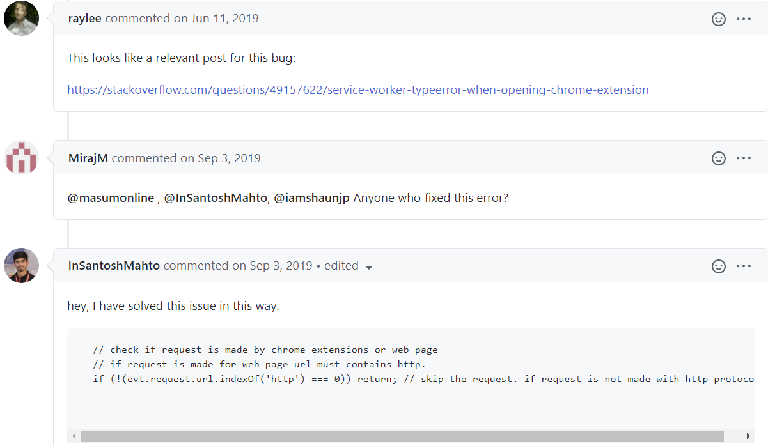

**Using the code from this post it did not work but when I launched in a browser without chrome extentions it did work.**

This is edge

